|  |  |  |  |  |  |  |
| --- | --- | --- | --- | --- | --- | --- |
| Node1(10) | Node2(3) | Node3(5) | Node4(6) | Total load | Time taken for Load Balancing | Time taken for Random |
|  |  |  |  |  |  |  |
| 0.8 | 0.5 | 0.6 | 0.2 | 2.1 | 5730 | 5926 |
| 0.2 | 0.2 | 0.2 | 0.2 | 0.8 | 4878 | 5566 |
| 0.8 | 0.8 | 0.8 | 0.8 | 3.2 | 6235 | 5953 |
| 0.1 | 0.5 | 0.2 | 0.9 | 1.7 | 12597 | 11906 |
| 0.5 | 0.5 | 0.5 | 0.5 | 2 | 5889 | 5392 |

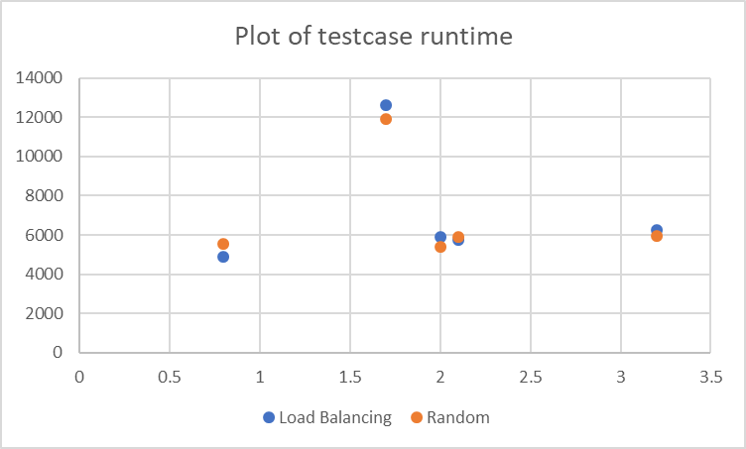

One common observation is, the time taken for random scheduling is always less than the time taken by load balancing because in load balancing we discard tasks based on the load of the compute node and again they are retried. From the plot we can see that when the total load increases the time taken by both the scheduling also increases because we do load injection based on the load of the compute nodes. There are some exceptions in the above mentioned trend. We can see that in testcase 4 the total time taken is well above others whereas the time taken is less. This may happen due to load on the server due to different clients.